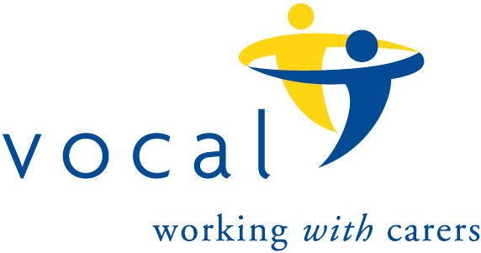The 100 Club

*Prize Draw number 151*

*Results for October, 2024 draw.*

|  |  |  |
| --- | --- | --- |
|  | *Name* | *Winning Number* |
| 1st Prize | *McDonald Arnot* | *20* |
| 2nd Prize | *Ana White* | *43* |
| 3rd Prize | *Whitfield Jill* | *15* |
| 3rd Prize | *Charles Dennis* | *56* |
| 3rd Prize | *McLoughlin (Parr) Rosie* | *78* |
| 3rd Prize | *Martin Dunn* | *87* |